**Name:- Dhanshri Vijay More**

**Roll No:- 101**

**Practical No:- 01**

**Practical Name:-** Set up a GitHub account and send an email message to friend telling to telling to your friend about the account**.**

**Create a GitHub account:**

If you don’t already have a GitHub account, here’s how to create one.

1. Open <https://github.com> in a web browser and then select **Sign up.**

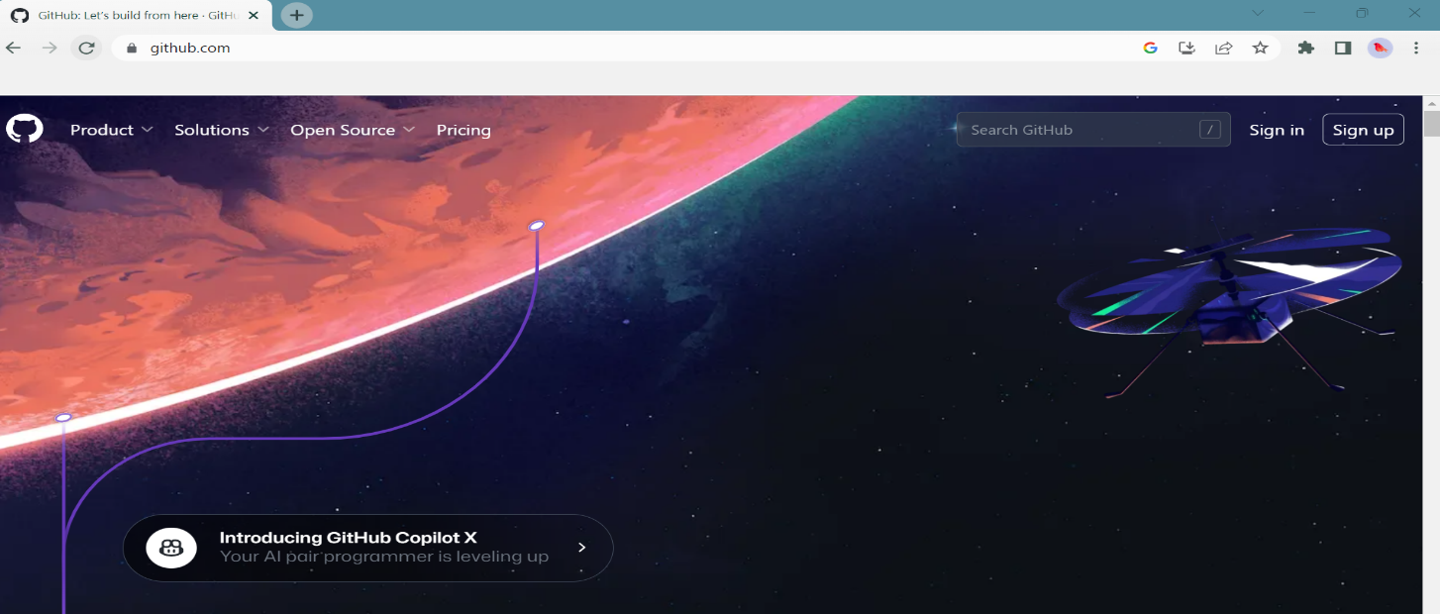

1. **Enter your email** address.

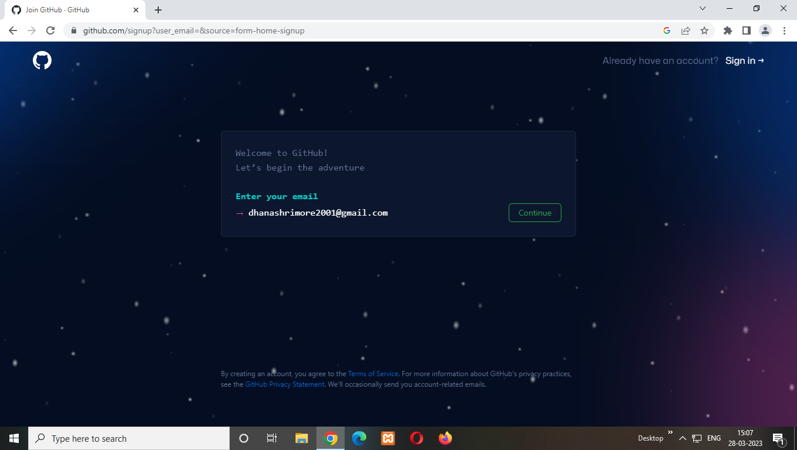

1. **Create password** for your new GitHub account, and **Enter a username,** too. Next choose whether you want to receive updates and announcement via email , and then select **continue.**

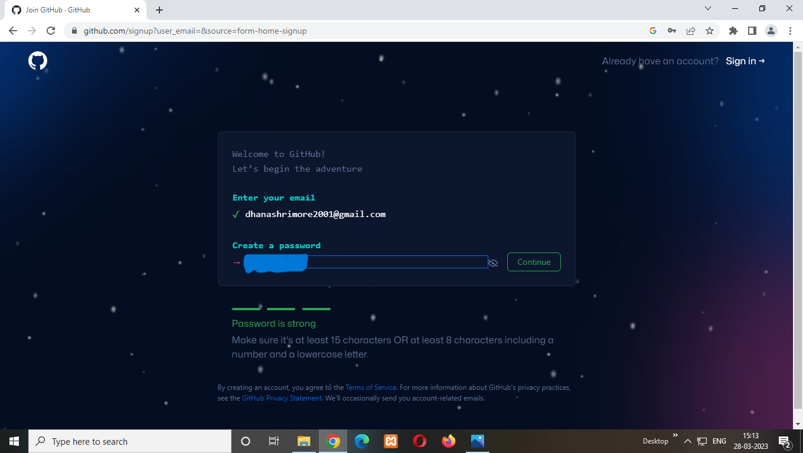

1. **Verify your account** by solving a puzzle. Select the Start Puzzel button to do so ,and then fallow the prompts.
2. After you verify your account, select the **Create account** button.
3. Next , GitHub sends a lunch code to your email address. Type that lunch code in the **Enter code** dialog, and then press **Enter.**
4. GitHub ask you some questions to help tailor your experience. Choose the answers that apply to you in the following dialog:

* **How many team members will be working with you?**
* **What specific features are you interested in using?**

1. On the **Where teams collaborate and ship** screen, you can choose whether you want to use the Free account or the Team account or the Team account. To choose the **Free** account ,select the **Skip personalization** button.

GitHub opens a personalized page in your browser.

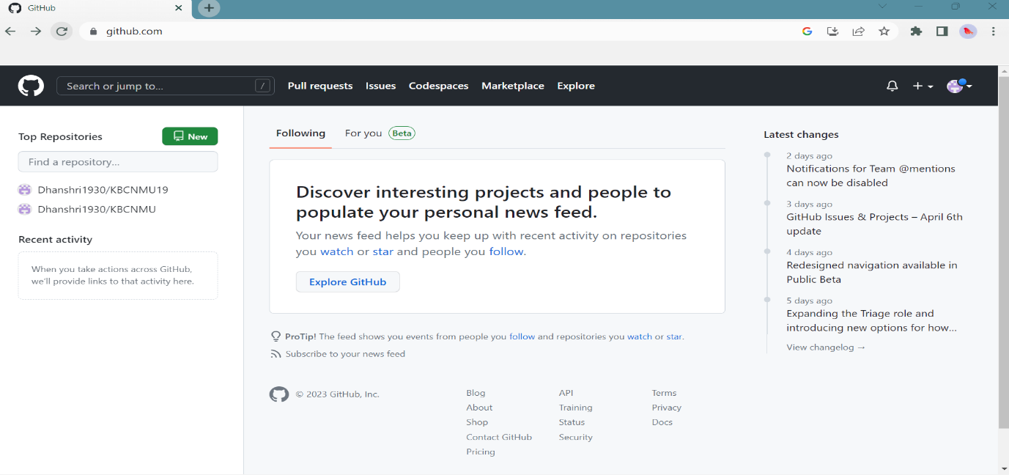

Congratulations! You’ve successfully created your GitHub account.

**Paste the screen shot of email which you had sended to your friend through GitHub.**

